PARISH COUNCIL OF RISTON
East Riding of Yorkshire

VACANCY FOR

COUNCILLOR

- There is a vacancy on the above Council caused by
Resignation of STEVEN TURNER
- A by-election to fill the vacancy will be held if by 15TH OCTOBER 2026 10 electors for the Town/Parish Council give notice in writing to the Chief Executive of the East Riding of Yorkshire Council at County Hall, Beverley, East Riding of Yorkshire
HU17 9BA claiming such an election.

- If no such notice is given the Parish Council will fill the vacancy by co-option.

Any written requests calling for an election to fill the vacancy will be available for public inspection and copying under Section 228(5) of the Local Government Act 1972...

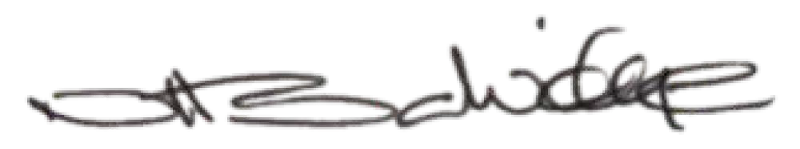
Date: 25/09/2026
Signed:

Clerk

Address:
17, Spring Field Close Sigglesthorne
HU11 5QP

Telephone Number: 07533 729173 Email: nsalvidge22@btinternet.com

